Data analysis project

Analysing CO₂ Emissions and Fuel Consumption of Gas-Powered Vehicles
Submitted by: Yassin Sameh(23-101192), Saif Alaa Eldin Fathy(23-101113), Yousuf Idrees(23-101077), Omar Sayed(23-101091)

Introduction:
One of the major contributors to CO₂ emissions is the transportation sector, with gas-powered vehicles accounting for a significant share. This project explores the relationships between various vehicle characteristics such as engine size, fuel type, transmission system, and vehicle class and their impact on fuel efficiency and CO₂ emissions. Using a dataset containing specifications for 1000 gas-powered vehicles, we perform exploratory data analysis to identify key trends and correlations. The goal is to uncover how these features influence pollution levels and to provide insights that can guide efforts in promoting cleaner, more efficient transportation options.

Research question:
Does vehicle characteristics and fuel type most significantly affect CO₂ emissions in gas-powered cars?

Hypothesis:
We failed to reject the Null hypothesis. There is no relation or weak relation between the vehicle’s characteristics and CO₂ emissions in gas powered vehicles. City vs Highway Fuel Consumption a highly significant difference was detected: vehicles consume more fuel in city.

Analysis:
First, we constructed a scatter plot that visualizes the relation between the engine size and the CO₂ emissions. The x axis shows the engine size and y axis shows the CO₂ emissions.

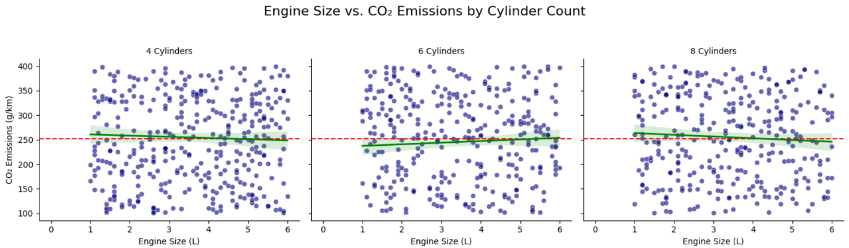

Then, we constructed a bar chart that visualizes the percentage between the fuel type and the vehicle classes.
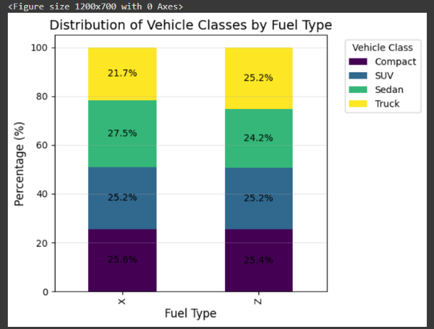

Then, we constructed a bar chart that shows the CO₂ emissions and vehicle type and the fuel type.
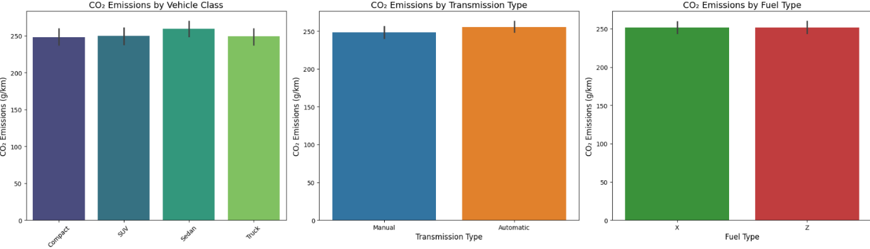

Conclusion:
This study analysed multiple factors potentially affecting CO₂ emissions and fuel consumption in gas-powered vehicles. Through hypothesis testing using Z-tests, ANOVA, and Chi-squared tests, we investigated the influence of engine characteristics, fuel type, and vehicle class on emissions and efficiency.
Number of Cylinders (4 vs 6)
No statistically significant difference in CO₂ emissions was found because the p value was greater than alpha. Also, between the engine size and CO₂ emission and the vehicle classes. City vs Highway Fuel Consumption a highly significant difference was detected: vehicles consume more fuel in city.

